Project Number 2: Python Mini Project

Information:

* Project = Dice rolling simulator
* Name = SAAD KHAN
* Email = saadkhanenterpreneour@gmail.com
* Father name = Aleem khan
* Contact = 0317-8515520

# Description:

1. The code begins by importing the **random** module, which is used for generating random numbers.
2. The **roll_dice** function takes two arguments: **num_dice** (the number of dice to roll) and **num_sides** (the number of sides on each die). It simulates rolling the specified number of dice with the specified number of sides and returns a list containing the result of each roll.
3. The **main** function is defined, which is the entry point of the program. It contains a while loop that runs indefinitely until the user decides to stop.
4. Inside the while loop, the user is prompted to input the number of dice and the number of sides for each die.
5. If the user enters values less than or equal to zero for either the number of dice or the number of sides, a message is printed indicating that valid values must be greater than zero, and the loop continues to prompt the user again.
6. If valid values are entered, the **roll_dice** function is called with the provided inputs, and the result of rolling the dice is printed.
7. After printing the result, the user is asked if they want to roll again. If the user responds with anything other than "yes" (case insensitive), a thank you message is printed, and the loop breaks, ending the program.
8. Finally, the **main** function is called when the script is executed, ensuring that the code inside it runs.

# Algorithum:

**Dice Rolling Simulator Algorithm**

**Author: [Your Name]**

**Date: [Date]**

**1. Start**

**2. Input:**

* Prompt the user to enter the number of dice to roll and the number of sides for each die.

**3. Validate Input:**

* Check if the entered values for the number of dice and number of sides are greater than zero.
* If not, display an error message and go back to step 2.

**4. Roll Dice:**

* Generate random numbers for each die rolled, within the range of 1 to the number of sides.

**5. Display Results:**

* Print the results of rolling the dice.

**6. Ask for Re-roll:**

* Prompt the user if they want to roll again.

**7. Validate Re-roll Input:**

* Check if the user's input is "yes" or "no".
* If not, display an error message and go back to step 6.

**8. Repeat or End:**

* If the user wants to roll again (input is "yes"), go back to step 2.
* If the user doesn't want to roll again (input is "no"), display a thank you message and end the program.

1. **End**

# Screenshot:

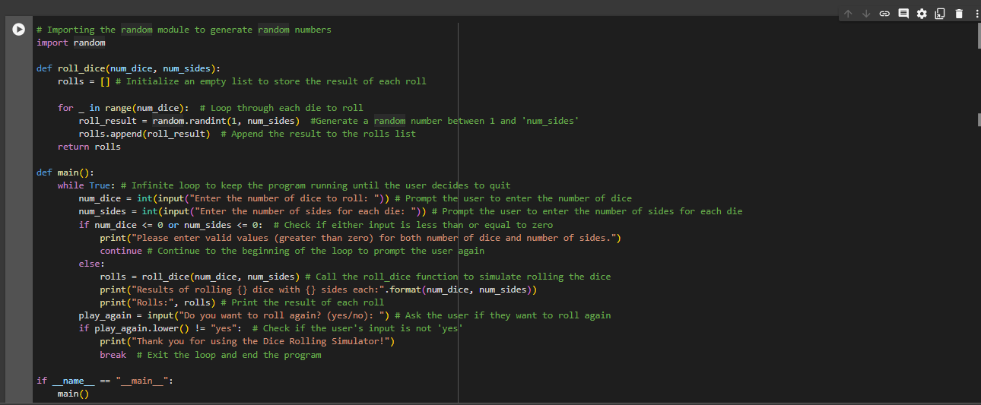

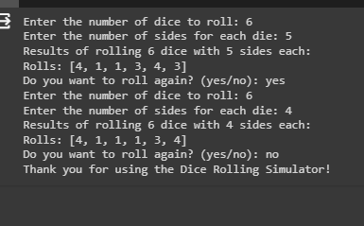

# githublink: